**8051 Flag Bits or PSW Register**

* The program status word (PSW) register is an 8-bit register, also known as flag register. It is of 8-bit wide but only 6-bit of it is used. The two unused bits are user-defined flags. Four of the flags are called conditional flags, which means that they indicate a condition which results after an instruction is executed. These four are CY (Carry), AC (auxiliary carry), P (parity), and OV (overflow). The bits RS0 and RS1 are used to change the bank registers.

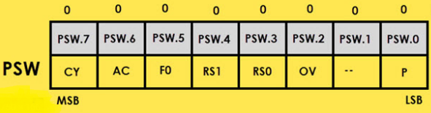

* We can select the corresponding Register Bank bit using RS0 and RS1 bits.

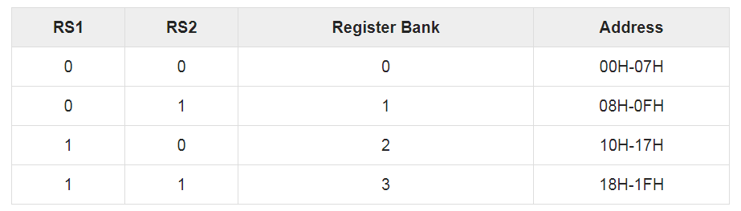

* **CY, the carry flag** −The carry flag is set (1) whenever there is a carry out from the D7 bit. It is affected after an 8-bit addition or subtraction operation. It can also be reset to 1 or 0 directly by an instruction such as "SETB C" and "CLR C" where "SETB" stands for set bit carry and "CLR" stands for clear carry.
* **AC, auxiliary carry flag** − If there is a carry from D3 and D4 during an ADD or SUB operation, the AC bit is set; otherwise, it is cleared. It is used for the instruction to perform binary coded decimal arithmetic.
* **P, the parity flag** −The parity flag represents the number of 1's in the accumulator register only. If the A register contains odd number of 1's, then P = 1; and for even number of 1's, P = 0.
* **OV, the overflow flag** −This flag is set whenever the result of a signed number operation is too large causing the high-order bit to overflow into the sign bit. It is used only to detect errors in signed arithmetic operations.

**Addressing modes of 8051**

* An Addressing Mode is a way to locate a target Data, which is also called as Operand. The 8051 Family of Microcontrollers allows six types of Addressing Modes for addressing the Operands. They are:
  + - Immediate Addressing Mode
    - Register Addressing Mode
    - Direct Addressing Mode
    - Register Indirect Addressing Mode
    - Indexed Addressing Mode
    - Implied Addressing Mode
* **Immediate addressing mode:** In Immediate Addressing Mode, the data is provided in the instruction itself. The data is provided immediately after the opcode. .The # symbol is used for immediate data.
* These are some examples of Immediate Addressing Mode.
  1. MOV A, #0AFH
  2. MOV R3, #45H
  3. MOV DPTR, #0FEH
* **Register addressing mode:** In the register addressing mode the source or destination data should be present in a register (R0 to R7). These are some examples of Register Addressing Mode.
  + 1. MOV A, R5
    2. MOV R2, DPL
    3. MOV R0, A
* In 8051, there is no instruction like MOV R5, R7. But we can get the same result by using this instruction MOV R5, 07H, or by using MOV 05H, R7. But this two instruction will work when the selected register bank is RB0.We have to add the starting address of that register bank with the register number. For an example, if the RB2 is selected, and we want to access R5, then the address will be (10H + 05H = 15H), so the instruction will look like this MOV 15H, R7. Here 10H is the starting address of Register Bank 2.
* **Direct Addressing Mode:** In the Direct Addressing Mode, the source or destination address is specified by using 8-bit data in the instruction. Only the internal data memory can be used in this mode. Here some of the examples of direct Addressing Mode.
* MOV 80H,R6
* MOV R2, 45H
* MOV 7, 2
* **Register indirect addressing Mode:** In this mode, the source or destination address is given in the register. By using register indirect addressing mode, the internal or external addresses can be accessed. The R0 and R1 are used for 8-bit addresses, and DPTR is used for 16-bit addresses, no other registers can be used for addressing purposes. Let us see some examples of this mode.

1. MOV/MOVX A, @R1
2. MOV/MOVX @DPTR, A

* In the instructions, the @ symbol is used for register indirect addressing. The X in MOVX indicates the external data memory (RAM). The external data memory can only be accessed in register indirect mode.
* **Indexed addressing mode**: In the indexed addressing mode, the source memory can only be accessed from program memory only. The destination operand is always the register A. These are some examples of Indexed addressing mode.

1. MOVC A, @A+PC
2. MOVC A, @A+DPTR

* The C in MOVC instruction refers to code byte. For the first instruction, let us consider A holds 30H. And the PC value is1125H. The contents of program memory location 1155H (30H + 1125H) are moved to register A.
* **Implied Addressing Mode:** In the implied addressing mode, there will be a single operand. These types of instructions are also known as register specific instruction. Here are some examples of Implied Addressing Mode.

1. RAL
2. SWAPA

* These are 1- byte instruction. The first one is used to rotate the A register content to the Left. The second one is used to swap the nibbles in A.

**8031/51 Interfacing With External ROM And RAM.**

* **Circuit diagram to interface external program ROM with 8051**
* **Step 1**: Connect EA pin to ground
* **Step 2**: Connect the PSEN to the CE and OE.
* **Step 3**: Then, Port 2 (P2.0 – P2.7) to A8 – A12 pins of ext. ROM.
* **Step 4**: Connect ALE to G of 74LS373 latch to enable it.
* **Step 5**: Next, connect the OC of 74LS373 to GND.
* **Step 6**: Connect Port 0 (P0.0 – P0.7), which consists of both address and data multiplexed into Port 0 to 1D – 8D pins of 74LS373 latch to demultiplex it and 1Q – 8Q of the latch to A0 – A7 of ext. ROM.
* **Step 7**: Connect Port 0 (P0.0 – P0.7) to D0 – D7 of the ext. ROM.
* **Step 8**: VPP of ext. ROM to VCC.

